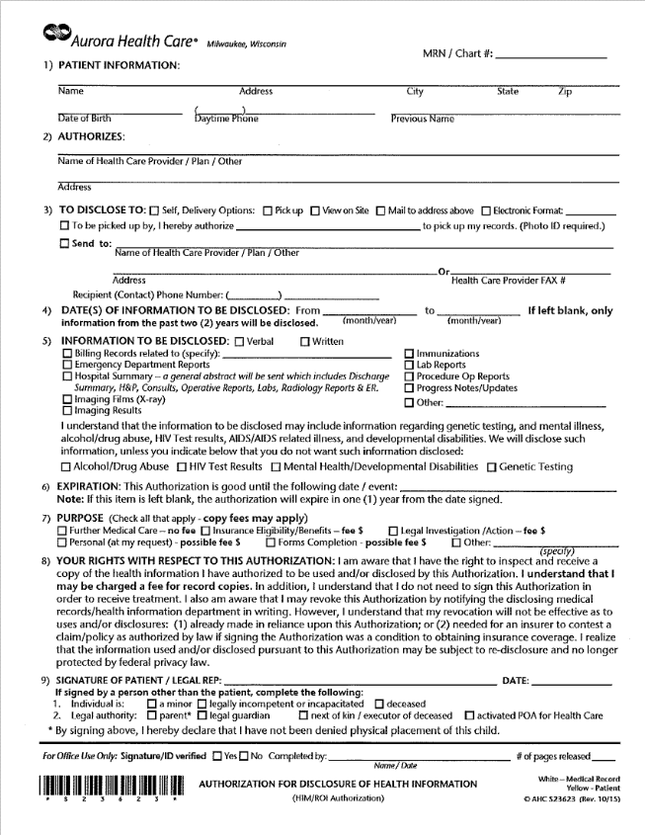

**Verbal communication**

**X**

**Aurora Health Care – Provider: __________________________________**

**305 McKinley Street, North Fond du Lac, WI 54937**

**X**

**X**

**School Nurse-NFDL School District: B.Amadon, RN, J. Shafer LPN, E. Voss, LPN**

**929-3754**

**920**

**X**

**X**

**School Nurse / School Health**

**X**